**UNIVERSITY OF GHANA**

LEGON



**DEPARTMENT OF DISTANCE EDUCATION**

**LEVEL 300**

**FIRST SEMESTER EXAMINATION**

**MINI PROJECT**

**(DCIT 307)**

**SHORT MESSAGING SYSTEM (SMS)**

**UTILITY PAYMENT SYSTEM**

**RUTH MAWUTOR KONOTEY**

**(10913771)**

**FEBRUARY 2023**

**CONTENT**

**ABSTRACT ……………………………………………………………………….. 2**

**PROJECT SIGNIFICANCE ……………………………………………….. 2**

**OBJECTIVE ………………………………………………………………………… 3**

**PROBLEM DEFINITION ……………………………………………………….. 4**

**PROPOSED APPROACH ………………………………………………………... 4**

**TIMELINE ………………………………………………………………………..**

**WORK DONE IN RELATION TO TIMELINE …………………………………**

**SUCCESSES AND CHALLENGES ………………………………………………**

**EXPECTED OUTCOME ……………………………………………………….. 7**

**REQUIREMENTS ………………………………………………………………… 7**

**APPLICATION AREA ………………………………………………………… 7**

**OTHER ISSUES ………………………………………………………………… 7**

**REFERENCE ………………………………………………………………… 8**

**APPENDICE ………………………………………………………………… 9**

**ABSTRACT**

Short Messaging System (SMS) Utility Payment System is an electronic commerce system that will use mobile platform for payment of utilities bills such as DSTV, electricity and water bills by consumers. Mobile electronic commerce (m-commerce) is a fast growing commerce in today’s modern world and secured for payment. It seeks to solve lots of problems associated with inconvenience, slow and delay access to payment of bills. Mobile phones are ubiquitous and a major contributor to the growth of m-commerce. This stems from the fact that, m-commerce brings package in convenience, speed and accessibility.

The obvious question is; is Ghana left out of m-commerce? The software engineers in Ghana can contribute their voices in aiding the author to echo “NO”. M-commerce is practised in Ghana. The system already exists in various dimensions that mostly uses mobile applications and Unstructured Supplementary Service Data (USSD). Available systems include ZeePay, G-Money, MTN MOMO, Vodafone Cash, Airtel-Tigo Cash, GH-Pay and other banking platforms accessible with short codes, but with shortcomings, because none of them support SMS payment. This system uses a simple message format.

This project seeks to solve the problem with utility bill payment and delivery of utility bills using a banking platform for accounts management and Short Message Service (SMS). The project would also review and try to solve the problems that are associated with already existing but slightly similar systems which uses USSD. The utility services the project seeks to interoperate with includes water, electricity and DSTV utilities.

**PROJECT SIGNIFICANCE**

The project when completed will solve the problems with utility payment using SMS which will initiate convenience, speed, dependability and accessibility. The project is significant both to the consumer and the utility service provider.

The consumer, who happens to be the user stands to benefit in the following ways:

* **Easiest and most convenient way to pay utility bills**

The consumer would be able to avoid long queues, traffic jams and waste of time just to pay utility bills. One can sit at the convenience of his/her office and pay bills using SMS.

* **Avoid late payment**

The system would be real time, which makes the payment instant at the moment the SMS is sent. One receives SMS to confirm successful payment. The consumer can even pay the bills in advance. This will erase the problem of forfeiting the utility service due to late payment. Since pay points for utility bills work during the normal work days and working hours, customers who are office workers find it difficult to pay their bills at the required time since they would be at work at these times. Therefore, with the introduction of this system, just the sending of an SMS any day at any time does the trick, thereby avoiding late payment.

* **Notification on monthly bills and bill request**

The consumer would receive SMS monthly on his/ her bills for the month which is optional during registration. This makes it easier for the consumer to access utility bills anytime and anywhere.

* **Accessibility**

Mobile phones are ubiquitous and once the consumer is in the coverage area of the respective network service provider, bill can be paid. The consumer can also access his/her statement on the payment of bill through SMS. This will be done in the form of report generation.

* **Security Guaranteed**

With the current way of delivering bills, the consumer is advised to leave behind his/her bills when out of the house to avoid disconnection when payment has been made. With residences where the metre is inside the house, leaving the bills behind indirectly means leaving their entrances or doors open which threatens their security. Additionally, the system is designed to pay only the bills of the registered person, this prevent individuals from using other people accounts through access to their phone to pay their own bills.

The merchant also stands to gain in the following perspective.

* **Reduction in cost in collecting bills and delivery of bills**

This project avoids direct payment and it is fully automated. Hence, cost involved in building of posts for bill collection, printing of receipts and human resource for bills delivery is avoided.

* **Payment is faster**

The consumers are directly debited from their accounts. Also consumers can make advance payment with the utility company. This would make payment more efficient and reliable.

* **Avoids risk of carrying money**

The risk of been robbed in carrying money to the bank is prevented. The money debited from the consumer’s accounts is credited to the utility company’s accounts with the bank. With more banks producing this service, there can be a centralized account that all other money can be deposited into for withdrawal.

**OBJECTIVE**

This project seeks to achieve these objectives:

* To make it convenient for people to pay their utility bills.
* To make the payment of utility bills instant and real time.
* To make it convenient for people to request for their bills.
* To aid in eradicating the time wasted in queues to pay utility bills.
* To aid explore and improve the services provided by banks and utility companies.

**PROBLEM DEFINITION**

The paying of utility bills in Ghana is always associated with joining long queues and wasting of time in traffic. Payment of such bills should not be that tiresome, stressful, demanding and difficult in this 21st century.

Also, the distribution of bills to individuals in the country is expensive and inefficient. The high cost stems from the fact that lots of money is used in human resource to achieve this aim. Also, due to the poor addressing system in Ghana, it is difficult to find various locations to deliver bills.

With the help of mobile phones and all these banks in the country, it should be easy to pay for your bills using SMS. Also, utility companies can make use of the ubiquity of phones to send bills to their customers.

**PROPOSED APPROACH**

With the ubiquity of mobile phones and the banks, SMS can be used to pay and request for the utility bills. SMS from the consumer is sent to a short code on any network to effect payment. To request for bills, SMS will be sent to a short code provided by the system.

**Merchant approach**

Different accounts for the individual utility companies will be created with a particular bank. The bank gets a respective short code (example 1770) from the different individual mobile telecommunication company. The customers need to know the short code and the simple procedure of the SMS in order to access the service.

A secured webpage will be built for the system for the one-time initial registration, or the chosen bank can do the registration from any of their branches, or incorporate it into their website. This can be used for the registration, update and verification of phone number. The webpage will have levels of security and user privileges due to the verification process. The consumer can only register and update information online after providing the correct login details. The bankers will not even be allowed to view the log in details. The verification PIN (Personal Identification Number) will only be sent to the consumer through SMS.

The system will have the database of all the consumers of the utility company they want to deal with for the system to work with. The database base should be updated daily.

The individual utility company will open an account with the chosen bank that seeks to use the system. This will enable the transfer of the money debited from the consumer’s accounts to be credited with the account of the utility company.

With the request of utility bills, the utility company would have access to the system to update the utilities bills. The SMS sent by the customers to the short code would be sent to the system and would be processed by the system and replied as such.

**Consumer approach**

The consumer can register online on the chosen bank website or at the branch of the bank. If the consumer wants to register by himself/herself, he/she logs on with his/her login details. The consumer provides further information such as phone number, customer ID on the various utilities and the maximum amount that can be transferred a day, National ID and passport picture. He/she will also provide the verification PIN that would be sent to the phone by SMS during registration for the various utilities which is part of security check. As part of the registration, a bank account would be opened for the consumer with the phone number as the account number, which money can be deposited personally or through other forms of online deposits or m-commerce. The consumer would then be sent a SMS with all the details of the completed registration.

To use the service, the consumer is expected to send SMS to the respective short code of the bank from the phone number used in registration. The SMS to be sent is in two types, payment of bill or request of bill. The type of utility should be provided and the amount for the bill payment. The request type is just for the request of the bill of which the latest monthly bill would be provided to the consumer. The customer receives an SMS for the process, be it successful or not.

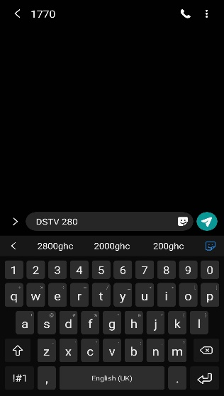**CUSTOMER BILL PAYMENT**

**<type_of_bill>space<amount>**

Example for a customer paying

GH¢280 for DSTV bill.

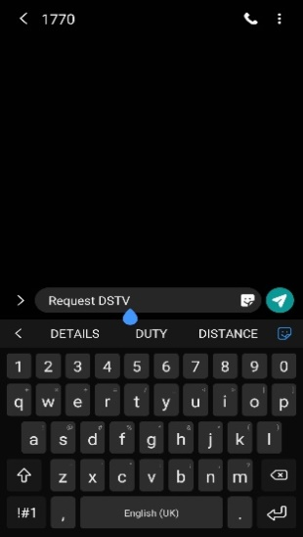

**BILL REQUEST FROM A CUSTOMER**

**<Request>space < type_of_bill>**

**System approach**

The database for the service will be created as part of the system. The SMS to the system would be received from the SMS Company. The system relates the chosen bank through the account created for the individual during the registration. The account number of the individual will be the phone number. This makes the phone number the only number which can transfer money from the customer’s bank account.

As a form of security, the customer’s account will **only** be debited if the following is **true**:

* **The SMS is from the phone number used for the registration.**
* **The format of the SMS is correct.**
* **The maximum amount provided is not exceeded.**
* **The amount of money in the customer’s account is enough.**

**Software Process Model**

The requirement for the system is not well defined and could change anytime. In order to enable the use of the rapid development method and accommodate any changes in the system requirement, the evolutionary development model is chosen. The evolutionary development model is more effective than other models like the waterfall model. The rapid development will help to deliver the software on time. The exploratory development is fundamental type of the evolutionary model that would be used. The customer apart from visiting the respective companies to give good requirement would be the supervisor of the project. The software will be exposed to the supervisor and changes in the requirement would be accommodated.

**TIMELINE**

The table below was the timeline drawn for the project in the semester.

**Table 1.0 Timeline for semester**

|  |  |
| --- | --- |
| **DURATION** | **SCHEDULED WORK** |
| **WEEK 1**  **28th  January – 3rd February 2023** | Project Preparation |
| **WEEK 2**  **4th – 10th February 2023** | Preparation of Presentation  Presentation of Project |
| **WEEK 3**  **11st – 17th February 2023** | Proposal Writing |
| **WEEK 4**  **18th -24th February 2023** | **Planning**  Feasibility Studies  Choice of Software Process Model  Submit Proposal to Supervisor |
| **WEEK 5**  **25th February -3rd March** | Requirement Document  Literature Review |
| **WEEK 6**  **4th - 10th March 2023** | **Design of Project**  Block Diagram  Drawing of UML Diagrams  (Block & Activity Diagrams) |
| **WEEK 7**  **11th – 17th March 2023** | **Design of Project**  Project Architecture  Drawing of UML Diagrams  ( Use Case & Class Diagrams) |
| **WEEK 8**  **18th – 24th March 2023** | **Development of Project**  Design of Database  (Bill Request Database) |
| **WEEK 9**  **25th March – 1st April 2023** | **Development of Project**  Design of Database  (Bill Payment Database) |
| **WEEK 10**  **2nd – 8th April 2023** | **Development of Project**  Writing of Source Codes  ( Commencement of Bill Payment Coding) |
| **WEEK 11**  **9th - 15th April 2023** | **Development of Project**  Preparation of Progress Report  Submission of Progress Report |
| **WEEK 12**  **16th - 22nd April 2023** | **Development of Project**  Writing of Source Codes  ( Commencement of Bill Request Coding ) |
| **WEEK 13**  **23rd - 29th April 2023** | **Development of Project**  Writing of Source Codes  ( Bill and Payment Request Coding )  Integration with Database |
| **WEEK 14**  **30th April – 5th May 2023** | Commencement of Thesis Writing |

**WORK DONE IN RELATION TO TIMELINE**

A presentation of the project was made in the second week of the first semester. Most of the students were present and the project was accepted and given the green light.

The proposal of the project was commenced in the third week to help elaborate the ideas in the project. The proposal covered topics in project significance, objectives, problem definition, proposed approach, expected outcome, requirements, application area and other issues. The proposal was however not submitted until the eight week due the some short comings on the part of the department.

As part of my efforts to get a credible system, during the fourth week I visited corporate entities to get wider views on the development of the system and how it will enhance their business if implemented. I visited three banks namely Ecobank, Standard Chartered Bank, and Barclays Bank. I also paid a visit to Electricity Company of Ghana. Some views gathered were very positive whilst others as always expected were negative. Also, even though some opinions were positive, the people involved were a little bit doubtful about the possible usage of the system after development since to them it was going to be lavish to implement. The utility companies spoken to were very happy about the system since they felt it will be a tote up to their already existing services. Electricity Company of Ghana for instance was so happy to hear of such a system and was very cooperative in giving some of the requirements they felt were suitable. Some of the requirements which they felt would be suitable were the account number; which is unique for identification, meter number, previous meter readings, current meter readings, arrears, unit cost and other fields necessary for the system.

During the writing of the proposal, the choice of the software process model imagined was the **evolutionary development model.** This is because the requirement for the system is not well defined and could change anytime. This model will also enable the use of the rapid development method and accommodate any changes in the system requirement. The evolutionary development model is more effective than other models like the waterfall model. The rapid development property of the evolutionary model would help to deliver the software on time. The exploratory development is also a fundamental type of the evolutionary model that would be used. The customer apart from visiting the respective companies to give good requirement would be the supervisor of the project. The software will be exposed to the supervisor frequently and changes in the requirement from him would be accommodated.

Concurrent Activities

**Outline Description**

**Specification**

**Validation**

**Development**

**Initial Version**

**Intermediate Version**

**Final Version**

**PHASE 1**

**PHASE 2**

fig. 1. Evolutionary Development Model

During the fifth week, a small **requirement document** was developed for the system. The requirement document seeks to define the requirement of the customer (user requirement), functional requirement, non-functional requirement, interface requirement and the domain requirement. The user requirement is satisfied if the user is able to use the system to pay and request utility bill at ease, accessibly, dependency and swift. The functional requirement enlightens on services that the system is expected to offer. The system should improve on the already existing systems for payment and request of utility bills. The non-functional requirement will make the system useless if not satisfied. This requirement is not directly concerned with the specific functions delivered by the system but properties like dependability, response time and store possession and memory require. It also defines the restraints on the system such as the organizational policies and rules which administer the system. The interface requirement is about how the interface should be design to reflect usability, attractiveness, convenience and accessibility. There will be interface for the application for registration and database access. Domain requirement is acquired from the application domain of the system which is the environment of operation rather than from the specific needs of system users. Failure to achieve the domain requirement may lead to the system working unsatisfactorily. The application domains of the system are the banks, utility companies and telecommunication companies. The requirement document helps to validate the system through using it to check if the final delivery has met the user request.

A detailed literature review was done on the system and it was found that a similar one was implemented in South Africa and India. In Ghana, companies like TxtnPay, Etranzact, and United Bank for Africa have implemented similar systems but still not well patronized. This is due to the fact that it is inconvenient and inaccessible to customers. The market of the system is also not enough to alert and inform the public. This project is designed to solve the problems the other systems could not solve.

The **design of the project** commenced in the sixth week. The Unified Modeling Language (UML) diagrams and block diagram were designed. The UML diagrams drawn included Use Case diagrams and Activity Diagrams. These diagrams are shown in the appendices. The tools used for the design were Netbeans Development Toolkit and Microsoft Word.

The design of the project continued in the seventh week. The UML diagrams designed included the Sequential Diagrams and the Class Diagrams. The architecture of the system, which is a two-tier using light client and heavy server, was designed. This means that the application of the system and the database would be ran on the server.

The database for the bill request was designed in the eighth week. This database would be sited at the utility company. MySQL database management system was used and the tool used for the design was MySQL Workbench which gives a graphical user interface. The design can be found in the appendices.

The database for the bill payment was designed in the ninth week. This database would be sited at the bank but would be synchronized with some tables at the utility company. MySQL database management system was used and the tool used for the design was MySQL Workbench which gives a graphical user interface.

The tenth week paved way for the commencement of the writing of the source codes for the bill payment side of the system. The various objects, structure and packages of the bill payment were developed. Some of the service objects and data object are already under development.

The eleventh week was used to prepare progress report which was due for submission at end of the week.

**SUCCESSES AND CHALLENGES**

**Successes**

As at now, the timeline for the implementation of the project has been drawn. The feasibility studies have been conducted and details concerning the implementation of the software conducted.

The software process model has been identified as evolutionary model and requirement document has been prepared. This was chosen with reason stated under the work done.

UML diagrams which include the Use Case, Activity, Sequential and Class Diagrams have clearly been designed. The block diagrams and architecture of the system have also been designed.

The databases for both the request and payment of bills have been expertly designed with the right tools. MySQL server was the database management tool used.

The coding has started with respect to the timeline but not just at the commencement phase. The timeline is being followed to the letter as the delivery of the software depend on it.

**Challenges**

Even though our progress is steady, we are facing a lot of difficulties.

For instance, the banks confronted, raised too many objections to the system because of security issues and cost of implementation.

Also, it has been difficult to see the database of the any utility company or bank because of security reasons. However, a dummy database has been design to work with the system.

With the design of the database, no course has been taken in database. It was therefore difficult designing it as extra time had to be taken to read about database. However, the internship the department promotes students to undertake gives some knowledge about how to do some of these things and helped very much.

Some of the banks like Ecobank felt that by trying to use the system, there would be issues with regard to security since banks were not going to be willing to allow third party software to ‘talk’ to their software. Most of these skeptical views were gathered from the banks.

**EXPECTED OUTCOME**

The project is expected to solve the problem associated with paying and distribution of utility bills. Some of the problems include queuing, time wasting and stack in traffic jam, inefficient bill distribution and expensive human resource.

**REQUIREMENTS**

The tools required include:

* Java Editor (Net Beans)
* Computer
* Phone number for testing
* Database from utility company
* MySql Server
* Apache Server
* Java Server Pages (JSP) and PHP

**APPLICATION AREA**

The area of application includes:

* Bank
* Utility Company
* Telecommunication Company

**OTHER ISSUES**

The successful implementation of this system will lead to a drop in inflation. Inflation which refers to a rise in prices of commodities that causes the purchasing power of a nation or market to fall has always been a major threat to the economy of Ghana.

With too much money in circulation, inflation tends to rise, which leads to instability of the national economy. Hence with the introduction of this system, physical transaction with money will be reduced since a lot of people will like to bank for convenience.

Also inflation can be caused by international lending and national debts. As nation borrows money, it has to deal with interests, which in the end cause prices to rise as a way of keeping up with its debts.

A successful implementation of the system therefore, would help the government to borrow money from its own local banks. This is because customers would save most of their monies with the banks if the system’s implementation is successful. This would reduce the effects of having to borrow from international bodies which come with high interest rates leading to an increase in inflation.

Inflation can also arise when government prints money every now and then to replace the defaced or bad ones. Therefore with this system in place, just a little percentage of money would be in circulation since the majority would be in banks. This would lead to the good condition of the chunk of the printed bills. Also, if the system is successfully implemented, government will not spend much money in printing new bills of money which sink the national coffers. This is because since just a little of money is in circulation, the majority of the money will be in good condition at every point in time

**REFERENCE**

David, A. G. (2002). **Software Engineering**. New York: McGraw-Hill Companies.

Faculty of Engineering and Applied Science (2008). **Software Engineering, Faculty of Engineering and Applied Science (FEAS)**. Canada: University of Ontario Institute of Technology. Available from: <http: [www.engineering.uotit.ca/undergraduate/software/](http://www.engineering.uotit.ca/undergraduate/software/)> [Accessed February 9, 2009].

Rucker, R. (2003). **Software Engineering (6th ed).** Pearson: Prentice Hall Publishers.

Sommerville, I. (2010). Software Engineering (6th ed). Pearson: Prentice Hall Publishers.

**APPENDICES**

**SMS FROM CLIENT**

**BILL PAYMENT SYSTEM AT BANK**

**BILL REQUEST SYSTEM AT UTILITY COMPANY**

**SMS COMPANY**

**DATABASE AT UTILITY COMPANY**

**BANK DATABASE**

Fig. 2. Block Diagram of the SMS Utility Service System

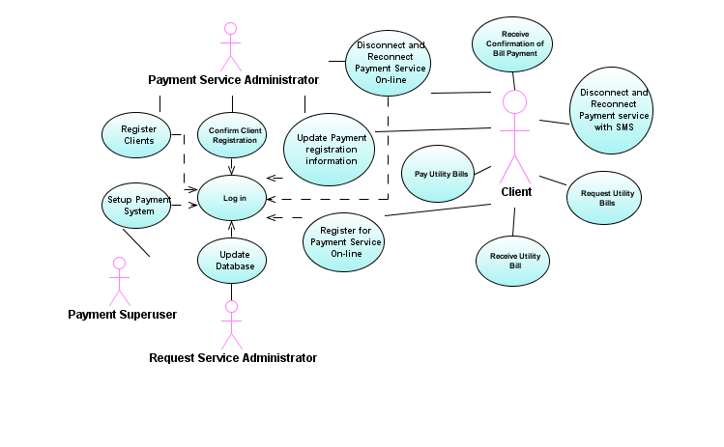

Fig. 3. Use Case Diagram of SMS Utility Service System

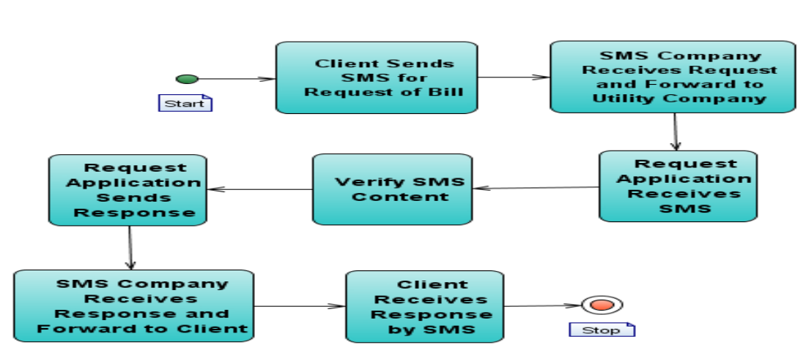

Fig. 4. Activity Diagram for Request Service of SMS Utility Service System

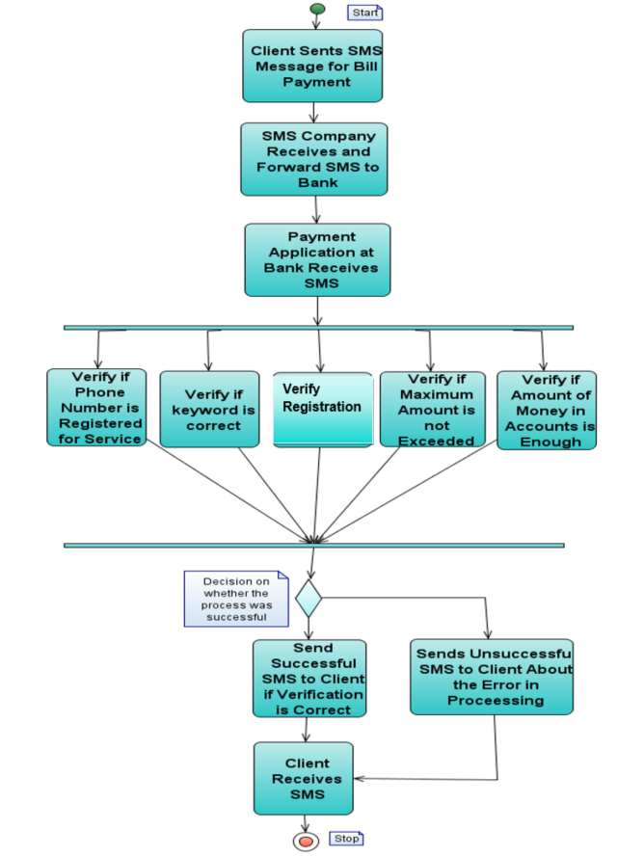

Fig. 5. Activity Diagram for Payment Service of SMS Utility Service System

**github link to project**

**https://github.com/AkuaSweety/DCIT-307-Ruth-Mawutor-Konotey-10913771-**